MENG 4010 - INDUSTRIAL NETWORKING

INTRODUCTION TO WIRESHARK SOFTWARE

Student Name & Number: Michaël R. McCorkell
Lab Date: September 16th, 2026

Objective
In this lab, students will install and use Wireshark, a network protocol analyzer, to capture and analyze packets. The primary focus is on examining the structure and behavior of key protocols such as IP, ICMP, TCP, and UDP, interpreting DNS lookups, and observing packet structures across the OSI model. Students will gain hands-on experience analyzing trace routes, TTL behavior, and protocol headers such as IPv4, TCP, and Ethernet.

Background
Wireshark is an open-source network protocol analyzer widely used in industry and academia for real-time monitoring, troubleshooting, and analysis of communication traffic. It allows detailed inspection of packet-level data across all layers of the OSI model, from the physical layer up to the application layer.

In the context of industrial networking, understanding protocol behavior at this level is essential for diagnosing latency issues, identifying misconfigured devices, and verifying the integrity of control system communication. Wireshark supports a broad range of protocols including ICMP, TCP, UDP, DNS, HTTP, Modbus, S7comm, etc., making it particularly valuable for analyzing both standard IT traffic and industrial Ethernet protocols.

Demonstration Requirements
To successfully complete the lab, students must demonstrate the following:

Part A – IP and ICMP Analysis Using Traceroute
- Wireshark Installation
  - Visit https://www.wireshark.org and install Wireshark (Windows Installer 64-bit).
  - During installation:
    - Accept defaults, install Npcap when prompted.
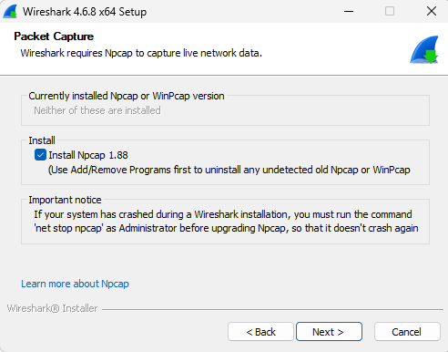
    - Do not install USBPcap.
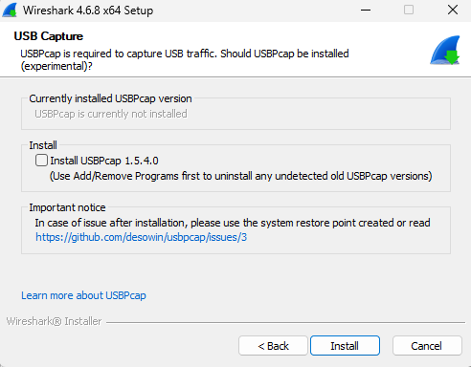
- Verify Network Info
  - In Command Prompt, type ipconfig /all
    - Note: Your IP address, Default Gateway, and MAC address
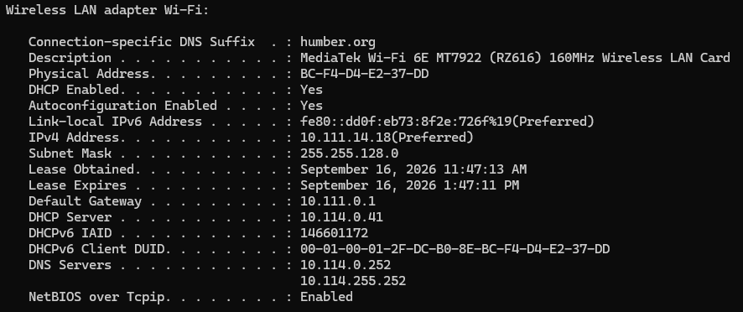
- Start Wireshark Capture
  - Open Wireshark.
  - Begin capture on the active Ethernet/Wi-Fi interface.
- Use TRACERT Command
  - In Command Prompt, type:
tracert www.netfirms.com
  - Let the trace complete (~30 seconds)
  - Observe increasing TTL values and reply sources.
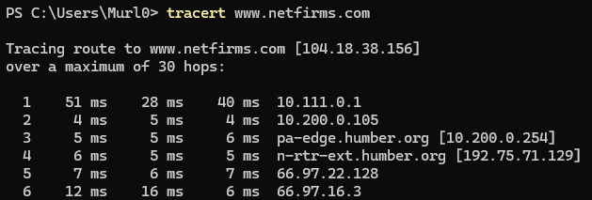
- Stop Capture in Wireshark
  - Save your capture file as Wireshark_ICMP_<YourName>.pcapng.

- Analyze Captured Packets
Use the filter bar and identify at least five of the following protocol types (if available in your capture):

Protocol | Purpose
ICMP✓ | Used by tracert and ping to test reachability
DHCP | Assigns IP addresses dynamically
ARP✓ | Resolves IP addresses to MAC addresses
DNS✓ | Resolves domain names to IP addresses
TCP✓ | Connection-oriented transport (e.g., HTTP)
UDP✓ | Connectionless transport (e.g., DNS, NBNS)
HTTP | Web traffic (if browsing was performed)
LLDP | Device discovery (used by industrial switches)

Inspection Instructions:
For each selected protocol:
- Apply the appropriate filter (e.g., type dns and press Enter)
- Select a representative packet
- Expand the following layers:
  - Ethernet II: Confirm source/destination MAC addresses
  - IPv4: Check source/destination IP addresses and port number
  - TCP/UDP/ICMP: Examine ports, flags, codes, or message types
- Take a screenshot of the expanded packet and include it in your report

ICMP:
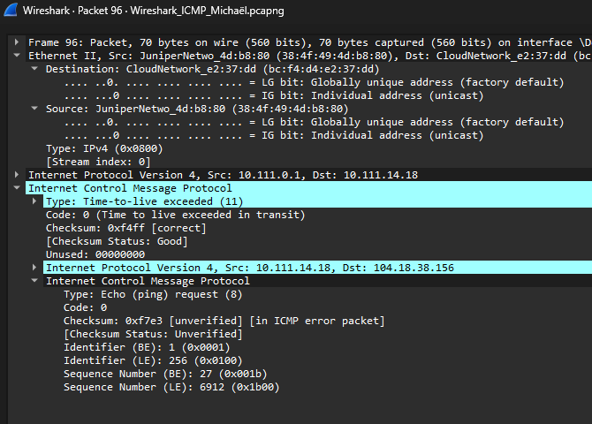
ARP:
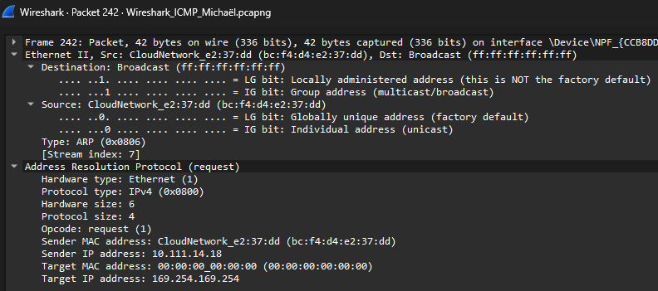

DNS:
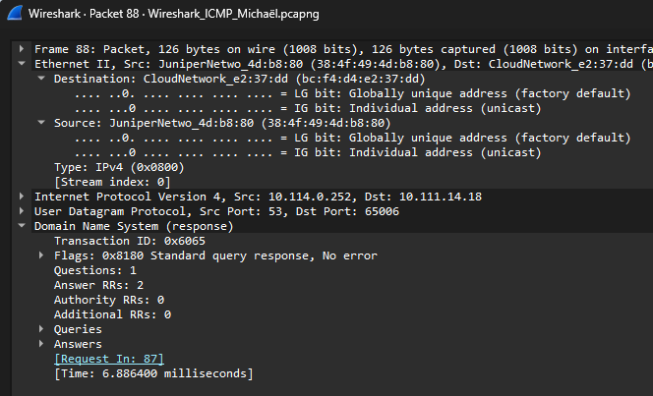
TCP:
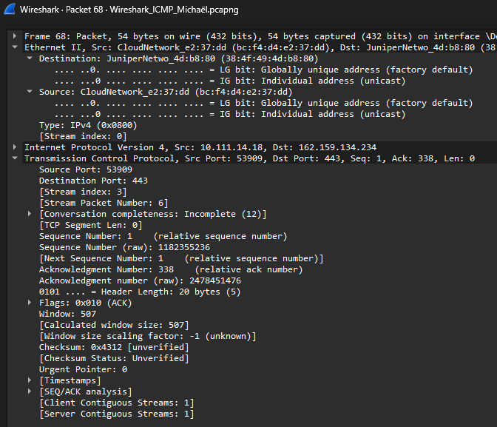

UDP:
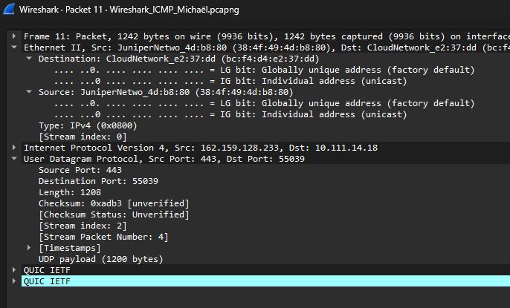

Part B – TCP and UDP Protocol Analysis
- Begin New Capture in Wireshark
  - Open this link in your browser:
http://www.textfiles.com/virus/datut010.txt
- Stop the Capture
  - Save it as Wireshark_TCPUDP_<YourName>.pcapng.
- Analyze TCP Packets
  - Filter using: TCP
  - Identify:
    - TCP 3-way handshake (SYN, SYN-ACK, ACK)
    - HTTP GET/Response pairs
    - Source/Destination IP and port
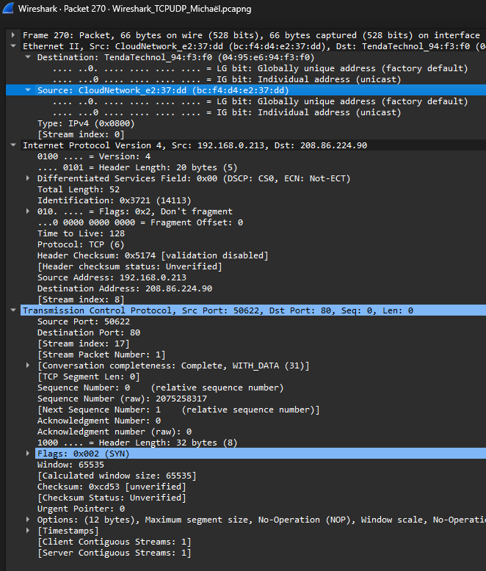
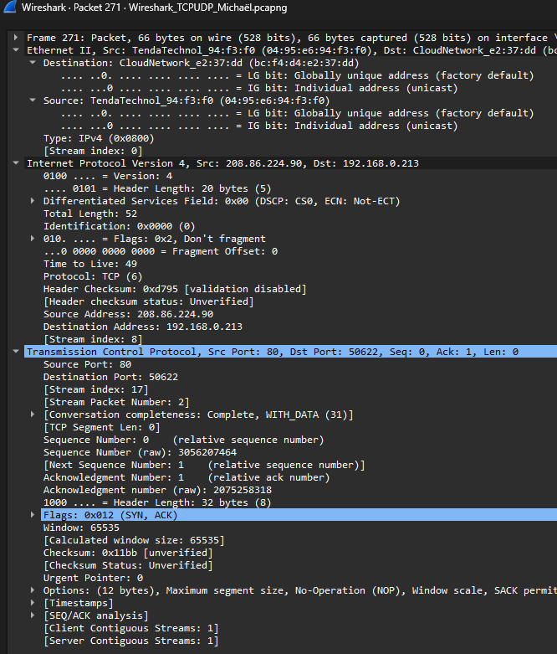
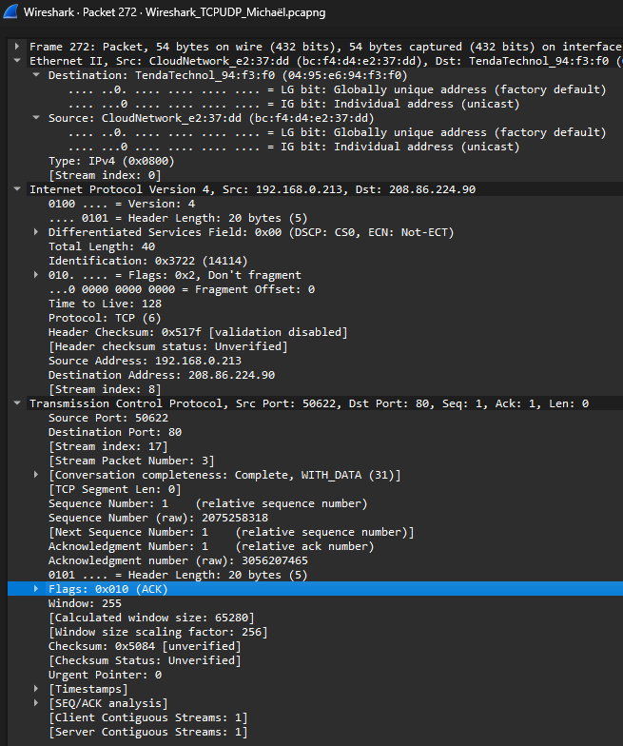

- Analyze UDP Packets
  - Filter using: UDP
  - Capture:
    - NBNS (NetBIOS Name Service)
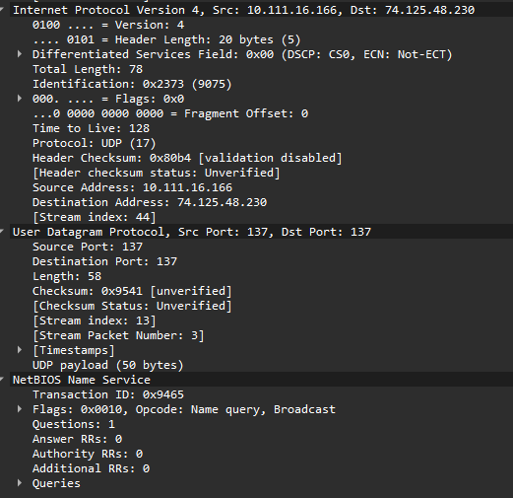

    - DNS
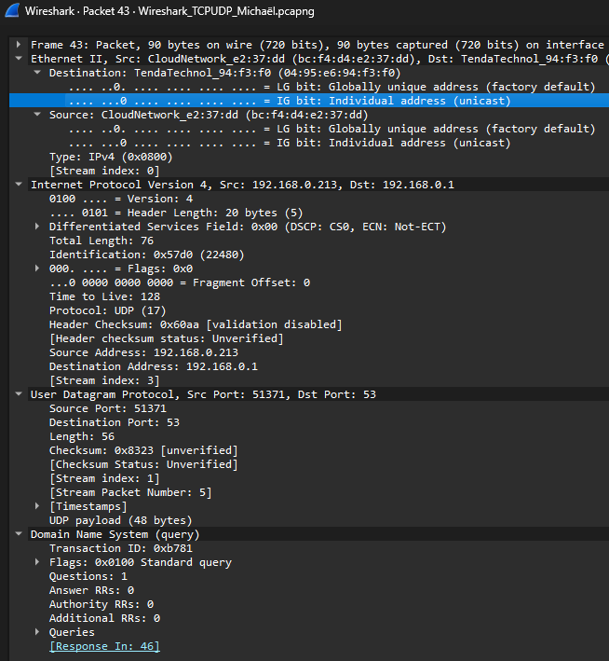

    - DHCP

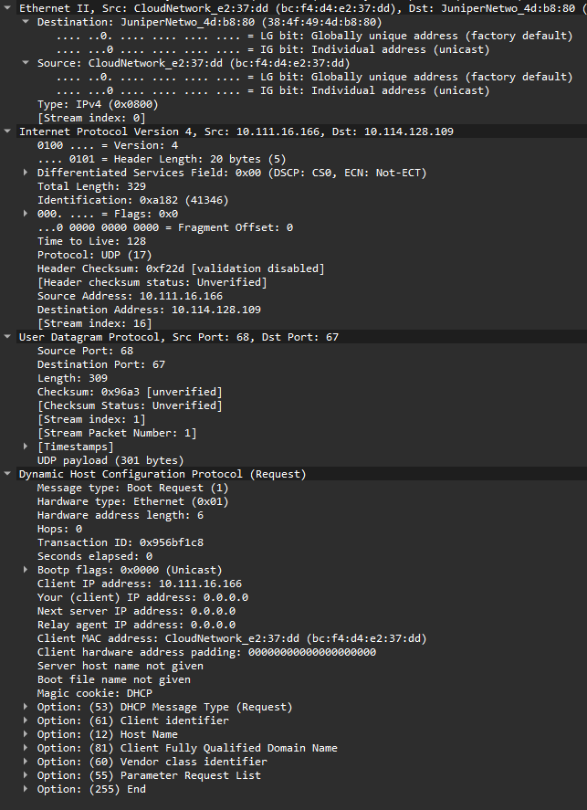

- Explore Protocol Headers
Take a screenshot of the expanded packet and include it in your report:
  - For TCP:
    - Note source port, destination port, sequence number, and ACK number
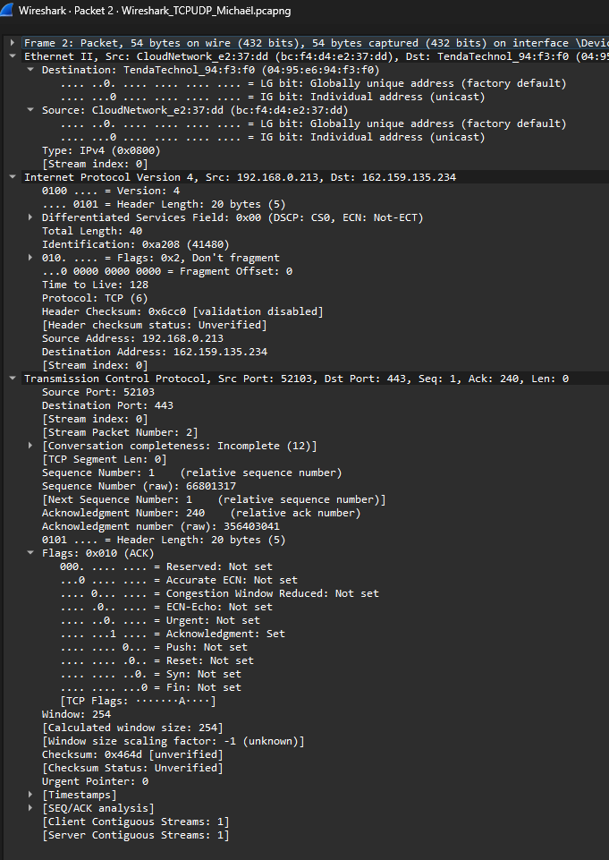

◦ For UDP:
▪ Observe connectionless structure and payload size
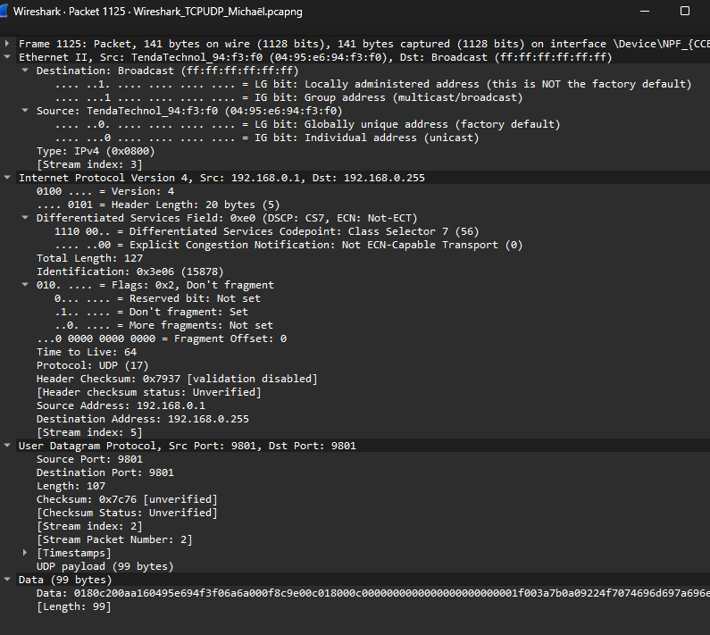
Part C – Exploring Local Network Commands and Protocol Behavior
This section focuses on using fundamental command-line tools to generate and observe network activity. Each command triggers specific protocol behavior that can be captured and analyzed using Wireshark.

- Use ping to generate ICMP traffic
- Open Command Prompt
- Type: ping 8.8.8.8
- In Wireshark, apply the filter: icmp
- Observe the Echo Request and Echo Reply packets
- Record the source and destination IP addresses and analyze TTL and sequence number values
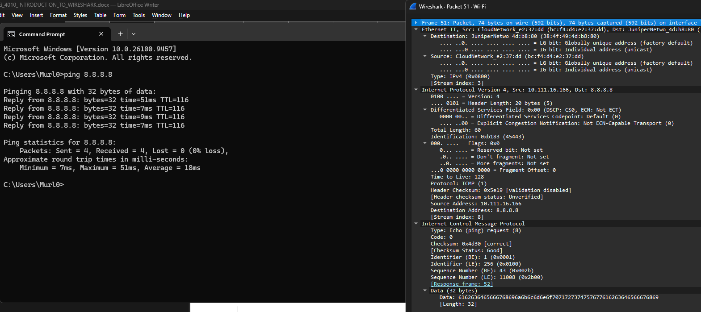

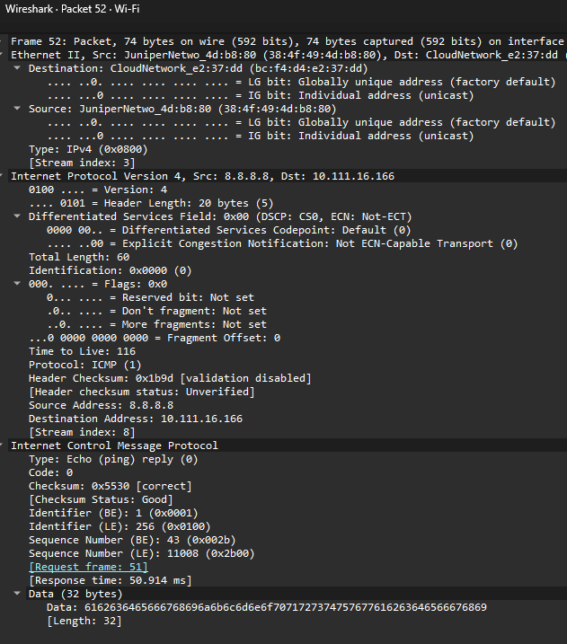

- Use arp to view MAC address resolution
- In Command Prompt, type: arp -a
- Review the list of IP-to-MAC address mappings in the ARP table
- In Wireshark, apply the filter: arp
- Locate ARP Request and Reply packets, and identify the sender/target MAC and IP addresses
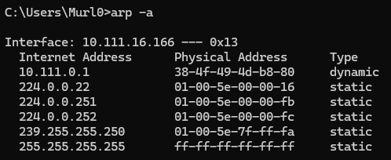
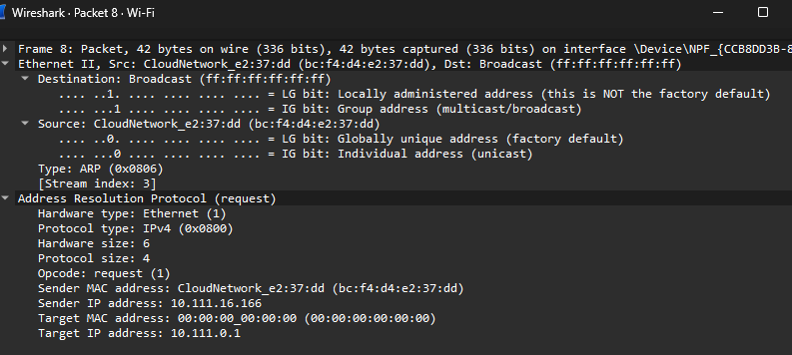
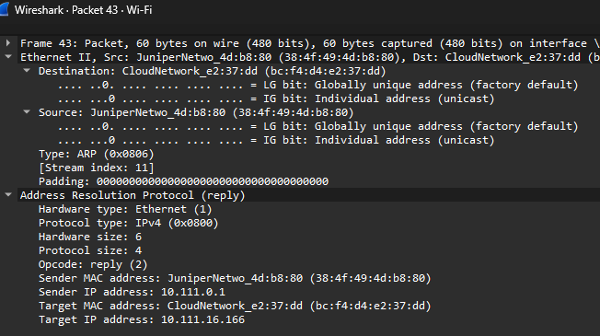
- Use ipconfig to review local network configuration
- Type: ipconfig /all
- Record your IP address, default gateway, subnet mask, and MAC address
- Cross-reference these values with those observed in Ethernet and IP headers within Wireshark captures
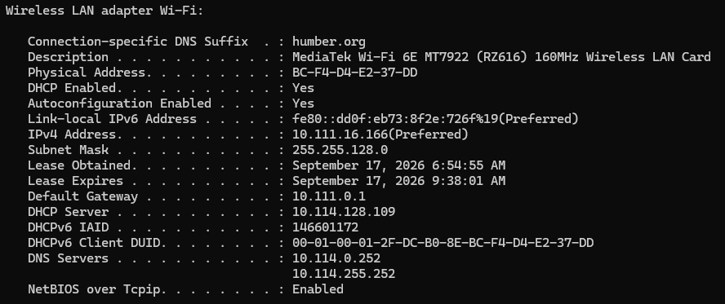
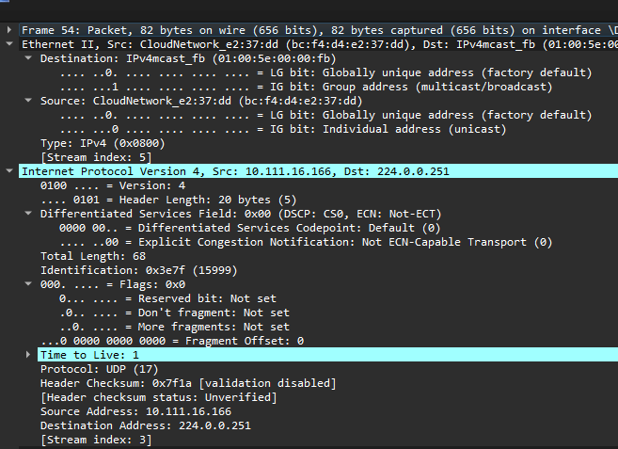
- Use netstat to view active connections
- Type: netstat -an
- Observe all active TCP and UDP ports and connection states (e.g., LISTENING, ESTABLISHED)
- In Wireshark, filter using: tcp or udp
- Match active port numbers with those seen in the packet list
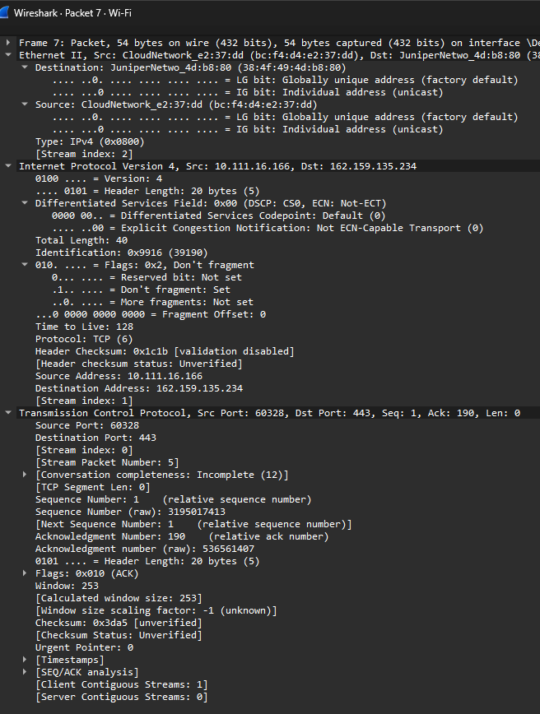
- Use tracert to trace the route to an external host
- Type: tracert www.google.com
- Let the trace complete
- In Wireshark, apply the filter: icmp
- Observe ICMP Time Exceeded messages from intermediate routers and the final Echo Reply from the destination
- Examine how the TTL value increases at each step
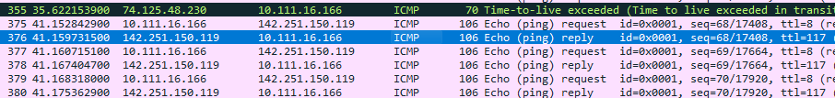
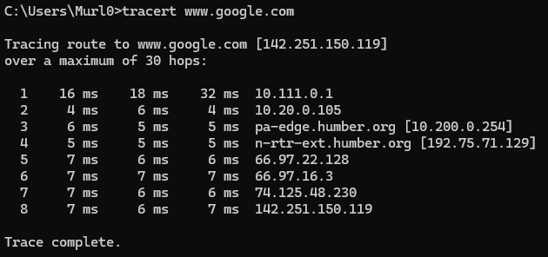
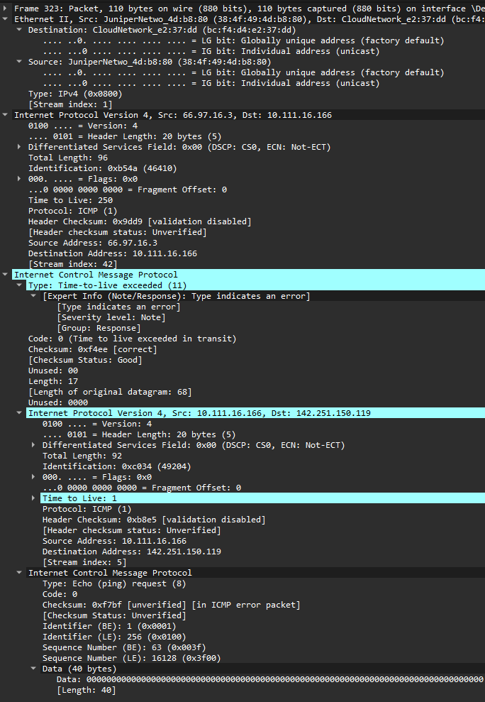
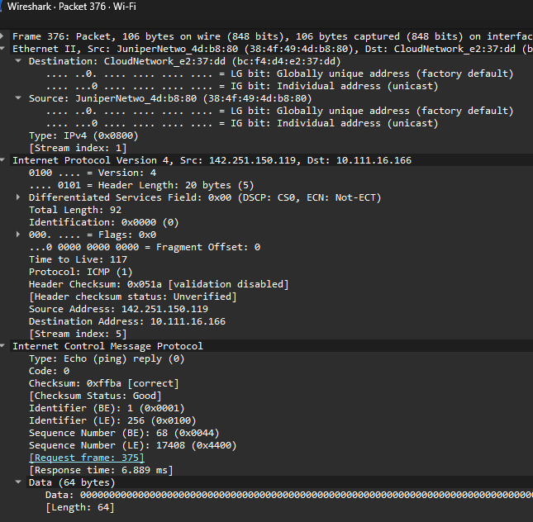

Optional Extension Task (Bonus)
Perform a Protocol Decomposition and Header Mapping
Choose one protocol (ICMP, TCP, DNS, or HTTP) from your capture, and for one frame:
- Expand the packet header and manually annotate each field using a reference table or protocol guide from the internet.
  - For IPv4: version, IHL, total length, protocol number, source/destination IP
  - For TCP: flags (SYN, ACK), window size, checksum
- Identify:
  - Byte offset
  - Field length (in bits or bytes)
  - Actual field value in decimal/hex

Lab Report Requirements
The lab report must contain:
- Instructor’s Confirmation
The course instructor’s signature is required to verify the completion of the lab. Please ensure this is included with your report’s submission.
- Assignment Summary
Provide a clear summary of the assignment, detailing the objectives, a description of the work completed, and your conclusions.

- Include the following in your lab report:
Part A – ICMP and IP Analysis (Traceroute)
- Screenshot of the tracert command output
- Wireshark screenshot showing filtered ICMP traffic
- One expanded ICMP packet (showing Ethernet, IP, and ICMP headers)
- Brief explanation of how TTL works and how routers respond with ICMP Time Exceeded messages
- Summary of observations (e.g., number of hops, IP addresses of routers)
Part B – TCP and UDP Protocol Analysis
- Wireshark screenshots showing filtered traffic for:
  - TCP (e.g., 3-way handshake or HTTP GET)
  - UDP (e.g., DNS, DHCP, NBNS)
- At least one expanded TCP and one expanded UDP packet
- Explanation of source/destination IPs and ports
- Summary of observed traffic types and their use cases
Part C – Command-Line Tools and Protocol Behavior
- Screenshots of command output for:
  - ping
  - arp -a
  - ipconfig /all
  - netstat -an
  - tracert
- Wireshark screenshots matching each command (e.g., ICMP for ping, ARP traffic for arp -a)
- Short written explanation linking each command to the network activity observed in Wireshark
- The lab report will be assessed based on the lab marking rubric provided on Blackboard. Please review the rubric to ensure all criteria are met.

Application Photos
